Fungal Foray 27th October 2011

21 attended this event - 4 coming from the Buckinghamshire Fungus Group (BSG). The Foray was let by Derek Schafer from the BSG. This event was to carry out a survey of Naphill Common to determine which fungi can be seen. There are more than 15,000 species of fungi named in Britain.

The morning was damp but ity did not rain. Derek started by telling us that this year was not a good year for fungi. Although it was wet on the surface the ground was very dry lower down. We started our foray from the Village Hall and made our way onto the Common via Chapel Lane (where we found our first fungus (this was noted but not included as being found on the Common).

From Chapel Lane we made our way along H21 to Dew Pond via Ash Pond. Many small fungi were found and this journey took over an hour.

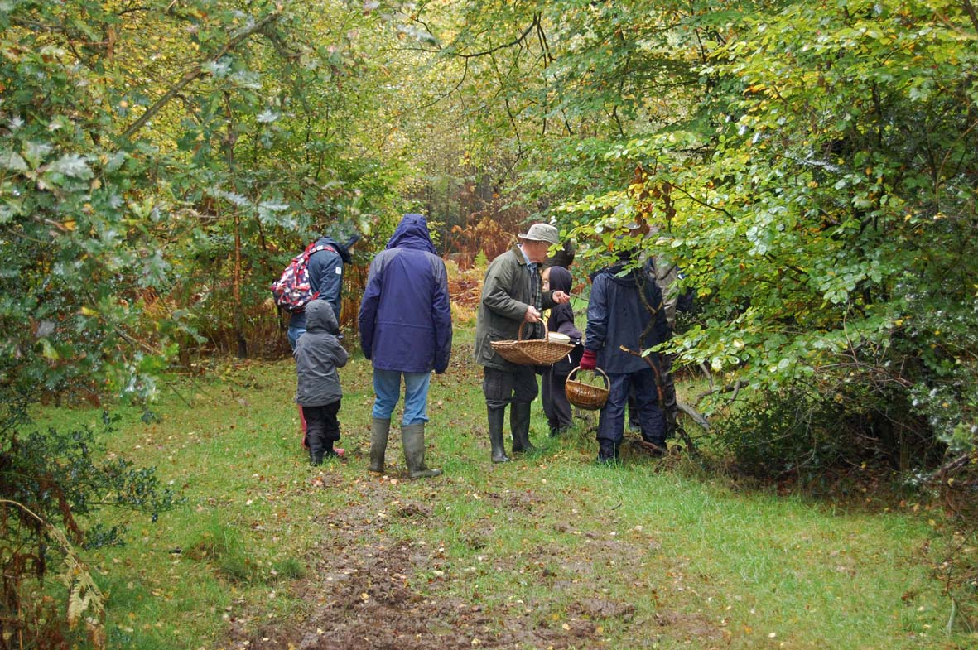
Intense interest being show over specimens found
(photo by Sheila Bottomley)

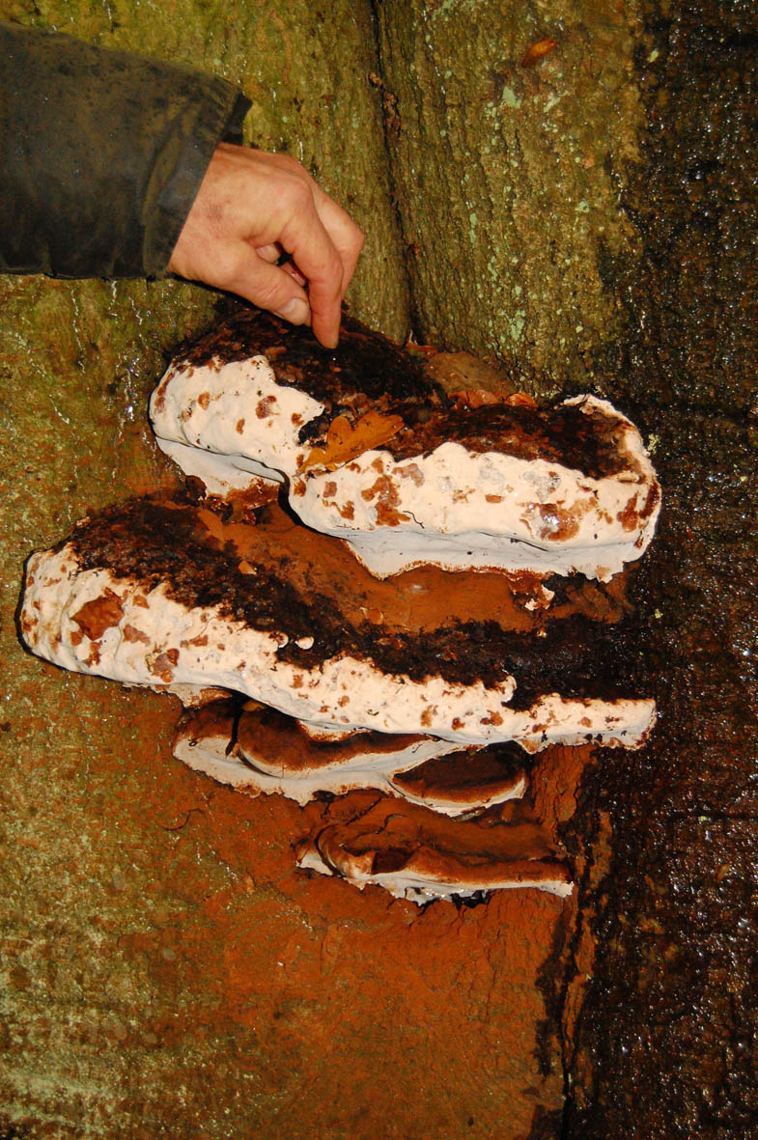
Bracket Fungus found on tree at Dew Pond
(photo by Sheila Bottomley)

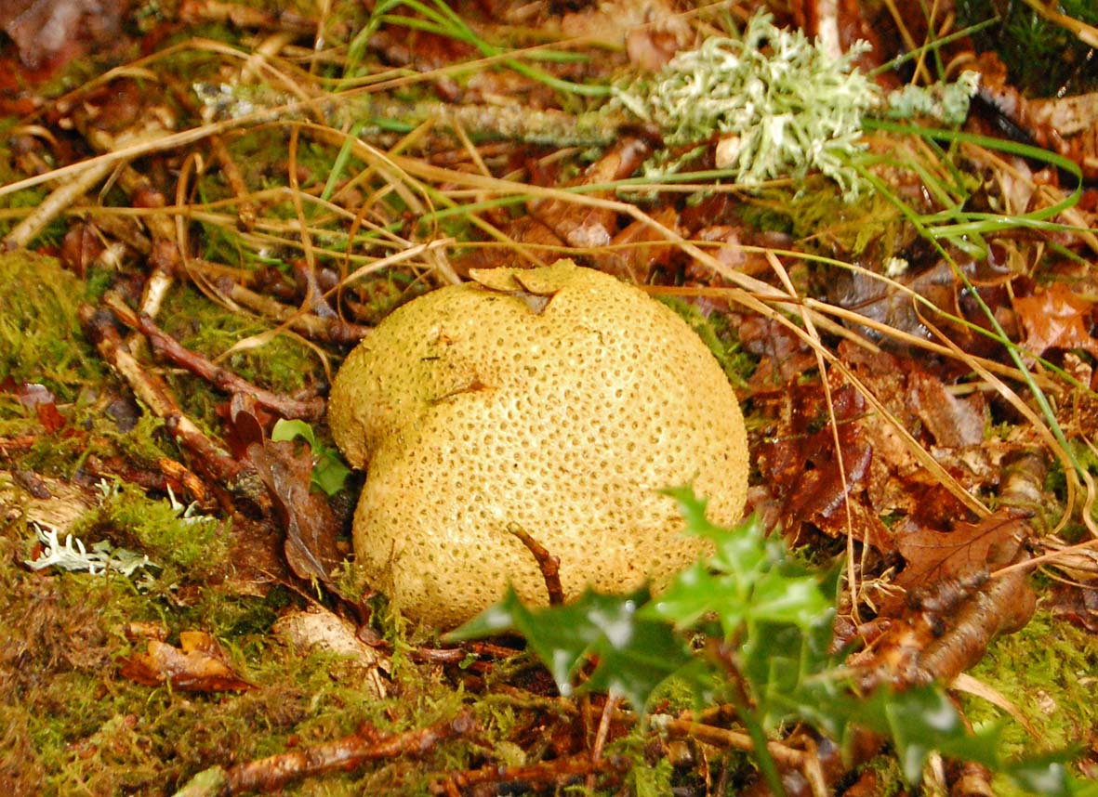
Common Earth Ball found (photo by Sheila Bottomley)

From Dew Pond we made our way along H2 where we found more fungi.

Two hours after we set off we returned to the Village Hall. A good time was reported by all. Our great thanks must go to Derek and his fellow members of BFG who gave up their time to help with this survey.

Click here for a list of fungi found during the foray.

